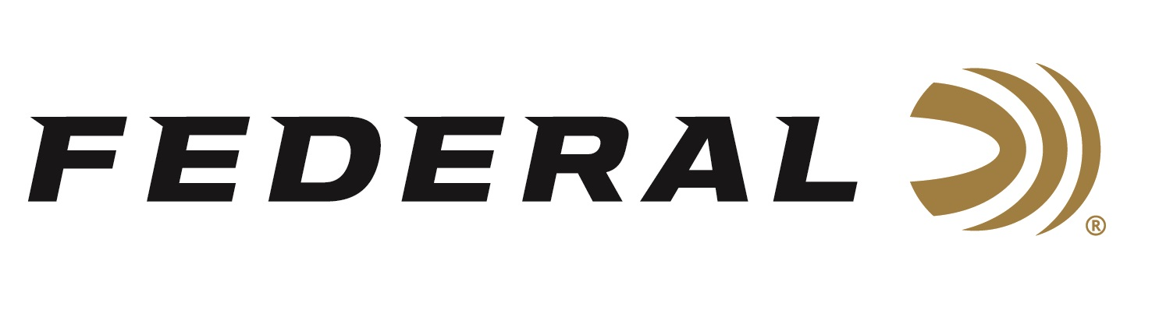

FOR IMMEDIATE RELEASE

50 Years of Protecting Hunting Rights on “It’s Federal Season” Podcast

ANOKA, Minnesota – January 21, 2021 – On this episode of the “It’s Federal Season” podcast, Ben Cassidy, SCI’s Director of Government Affairs, joins the team to discuss the organization’s dedication to conservation and the work it is doing on behalf of hunters for the past fifty years. Cassidy hits on several topics including what SCI is doing to end restrictive legislation in the U.S. and globally, its recruitment efforts, and the important passage of the Great American Outdoors Act.

Episode No. 17 - Working for Hunters
https://www.federalpremium.com/this-is-federal/podcast/

In the Tech Talk segment, Drew Goodlin, Sr. Director of New Product Development, discusses the construction of bullets designed for dangerous game animals and the performance characteristics needed to harvest one of Africa’s big five or a grizzly in North America. Before closing the podcast, find out what promotions are currently running and take advantage of some great offers from Federal Ammunition.

Federal Ammunition can be found at dealers nationwide or purchased online direct from Federal. For more information on all products from Federal or to shop online, visit www.federalpremium.com.

Press Release Contact: JJ Reich
Senior Manager – Press Relations
E-mail: VistaPressroom@VistaOutdoor.com

About Federal Ammunition
Federal, headquartered in Anoka, MN, is a brand of Vista Outdoor Inc., an outdoor sports and recreation company. From humble beginnings nestled among the lakes and woods of Minnesota, Federal Ammunition has evolved into one of the world's largest producers of sporting ammunition. Beginning in 1922, founding president, Charles L. Horn, paved the way for our success. Today, Federal carries on Horn's vision for quality products and service with the next generation of outdoorsmen and women. We maintain our position as experts in the science of ammunition production. Every day we manufacture products to enhance our customers' shooting experience while partnering with the conservation organizations that protect and support our outdoor heritage. We offer thousands of options in our Federal Premium and Federal® lines-it's what makes us the most complete ammunition company in the business and provides our customers with a choice no matter their pursuit.

